This amazing Live Auction Item (and others) is available for Proxy Bidding!!
** Auction Date: November 13, 2010 **

Offered by Jean Weingarten Peninsula Oral School for the Deaf 2010 Benefit Auction

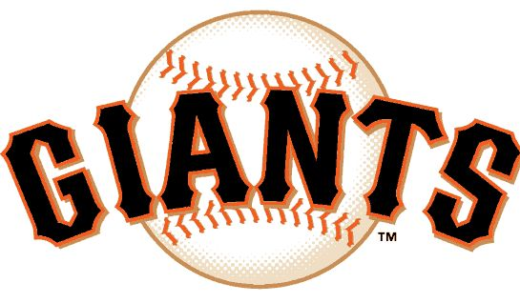
SF Giants Extravaganza
With David Righetti and Buster Posey!

You and three (3) of your friends are invited to the ballpark for an amazing day with
the San Francisco Giants 2010 NL West Champs!

The winner of this package will receive:
• Pre-game field visit to meet the players
• 4 game tickets in lower box seats
• Your own personalized Scoreboard greeting message
Plus, a grand slam bonus included in this package is
- autographed jersey by Buster Posey, 2010 NL July Player of the Month, 2010 NL July Rookie ofthe Month and drafted by the San Francisco Giants fifth overall in the 2008 Major League Baseball Draft.

This package offers much more than the traditional peanuts and cracker jacks! Raise your paddle to root for the home team!

Donor: Giants and Righetti Family
Value: Priceless!
To place a Proxy Bid: Complete the Proxy bidder form available at: (link to form)
To purchase tickets to the event: www.deafkidstalk.org/benefit
To view complete list of Live Auction Items (also available to Proxy Bidders): (link to catalog)

